(Revised) Regulation- 2020 (ESC)


Reg. No:

SRI RAMAKRISHNA ENGINEERING COLLEGE, COIMBATORE
(Autonomous Institution, Reaccredited by NAAC with ‘A+’ GRADE Approved by AICTE and Permanently affiliated to Anna University, Chennai)

AUTONOMOUS EXAMINATIONS - MAY'2024 COMMON TO B.E – CSE / B.TECH – IT / AI&DS &
M.TECH – CSE (5 YEARS INTEGRATED)

20EE262 - BASICS OF ELECTRICAL AND ELECTRONICS ENGINEERING
Answer ALL questions

Duration: 2 Hrs 30 min Maximum: 70 Marks
PART - A (5x 1 = 5 Marks)

CO1 A current of 5A is drawn by a filament of an electric bulb for 2 minutes. Find the amount of electric charge flows through the circuit.
a) 300 C b) 450 C c) 600 C d) 100 C

CO1 If there are 3 Resistors R1, R2 and R3 in series and V is total voltage and I is total current, then Voltage across R2 is .
a) VR3/(R1+R2+R3) b) VR2/(R1+R2+R3) c) VR1/(R1+R2+R3) d) V

CO2 Lamination of the transformer core is made of .
  - silicon steel b) cast steel c) aluminum d) cast iron

CO3 When a pentavalent impurity is added to a pure semiconductor, it becomes .
  - an insulator b) an intrinsic semiconductor
c) p-type semiconductor d) n-type semiconductor

CO4 The MOSFET is a device.
  - current controlled b) voltage controlled
c) frequency controlled d) power controlled

PART - B (5x 3 = 15 Marks)
- CO1 Find the value of current I coming out of the battery for the circuit in the figure?

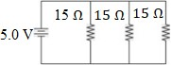

- CO1 State Kirchoff’s Voltage law and Kirchoff’s current law.
- CO2 Transformers ratings are expressed in kVA. Give reason.
- CO3 BJT can be used as an amplifier -Justify.
- CO4 Define calibration and give reason why it is important for an instrument.

PART - C (5 x 10 = 50 Marks)
Q.No: 11 Compulsory Question Q.No: 12 to 17 Answer any FOUR Questions
Compulsory Question:

- CO1 i) Determine the equivalent resistance across the terminals AB for the circuit.
(5)

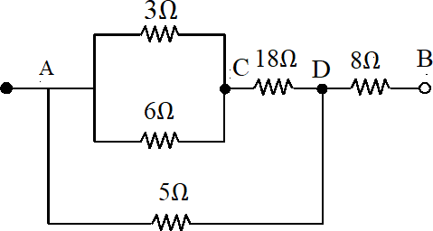

CO1 ii) Determine the mesh currents in the circuit using mesh analysis. (5)

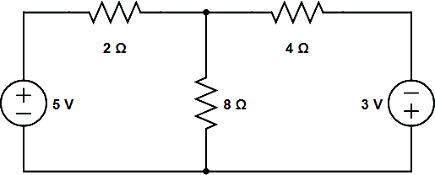

12. | CO1 |  | Determine the current through the 5Ω resistor in the circuit shown in  Fig.4 using Thevenin’s theorem.  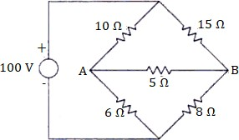 | (10)
13. | CO2 |  | Outline the construction of single phase transformer and explain the working principle of transformer. | (10)
14. | CO3 | i) | Outline the functional elements of an instrument with a neat diagram. | (5)
 | CO3 | ii) | Discuss the working principle of a moving coil instrument. | (5)
15. | CO3 |  | Explain the methods used for measurement of three phase power in three phase circuits. | (10)
16. | CO4 |  | Explain the construction, working, Characteristics, and applications of PN junction diode. | (10)
17. | CO4 | i) | With a neat sketch, explain the working of JFET. | (5)
 | CO4 | ii) | Explain the different regions of operations in the output characteristics  of MOSFET. | (5)
 |  |  | *****

